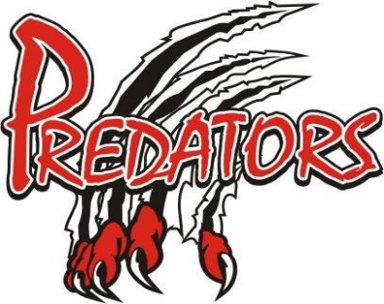Tryouts for the 2019 – 2020 Season

All Tryouts are at the Forest Arena

Wed Sept 4 5:00 – 6:00 pm Atom A – M
6:00 – 7:00 pm Atom N - Z

Thurs Sept 5 5:00 – 6:00 pm Peewee A- O
6:00 – 7:00 pm Peewee P – Z
7:00 – 8:30 pm Bantam All Players Hitting Clinic
8:30 – 10:00pm Midget All Players Hitting Clinic

Fri Sept 6 5:00 – 6:00pm Minor Novice All Players (2012)
6:00 – 7:00pm Major Novice A – M (2011)
7:00 – 8:00pm Major Novice N - Z (2011)
8:00 – 9:30pm Bantam All Players

Sat Sept 7 3:00 – 4:00pm Atom A – M
4:00 – 5:00pm Atom N – Z
5:00 – 6:00pm Peewee A – O
6:00 – 7:00pm Peewee P – Z
7:00 – 8:00pm Midget A – R
8:00 – 9:00pm Midget S – Z

Sun Sept 8 10:00 – 11:00am Instructional 2014 – 2016
11:00 – 12:00pm Instructional 2013
1:30 – 2:30pm Minor Novice All Players
2:30 – 3:30pm Major Novice A – M
3:30 – 4:30pm Major Novice N – Z
4:30 – 5:30pm Peewee
5:30 – 6:30om Peewee
6:30 – 8:00pm Bantam All Players
8:00 – 9:00pm Midget A – R
9:00 – 10:00pm Midget S – Z

Tryouts for the 2019 – 2020 Season

Mon Sept 9 5:15 - 6:15 pm Atom
6:15 – 7:15pm Atom

Tues Sept 10 5:00 – 6:00pm Minor Novice All Players
6:00 – 7:15pm Atom Tryout Game#1
7:15 – 8:30pm Peewee Tryout Game #1
8:30 – 10:00pm Bantam

Wed Sept 11 8:30 – 9:30pm Midget
9:30 – 10:30pm Midget

Thurs Sept 12 5:00 – 6:00pm Major Novice
6:00 – 7:00pm Major Novice
7:00 – 8:15pm Atom Tryout Game #2
8:15 – 9:45pm Bantam Tryout Game #1

Fri Sept 13 5:00 – 6:00pm Instructional 2014 – 2016
6:00 – 7:00pm Instructional 2013
7:00 – 8:15pm Peewee Tryout Game #2
8:15 – 9:45pm Midget Tryout Game #1

Sat Sept 14 3:00 – 4:00pm Major Novice
4:00 – 5:15pm Atom Tryout Game #3
5:15 – 6:30pm Peewee Tryout Game #3
6:30 – 8:00pm Bantam Game Game #2
8:00 – 9:30pm Juvenile 1st skate

Sun Sept 15 10:00 – 11:00am Instructional 2014 – 2016
11:00 – 12:00pm Instructional 2013
1:30 – 3:00pm Juvenile 2nd skate
Tryouts for the 2019 – 2020 Season

Sun Sept 15 3:00 – 4:00pm Minor Novice All Players 2012
4:00 – 5:00pm Major Novice
5:00 – 6:30pm Bantam Tryout Game #3
6:30 – 8:00pm Midget Tryout Game #2

Tues Sept 17 9pm to 1030pm Midget Tryout Game #3

