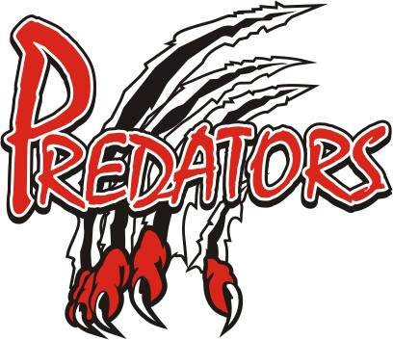Pre-Season Development Sessions

LSMHA Development Committee in conjunction with the Lambton Shores Minor Hockey Board are pleased to offer all the players registered in the Association a chance to take advantage of an affordable pre-season skate. This pre-season skate will give the players a chance to hit the ice, test new equipment and to continue to develop their individual player skills before the regular season commences.
A program leader will be selected for each age group and will design a program that will focus on age appropriate hockey skills. There will also be some time set aside at the end for some 3 on 3 game action or a fun scrimmage.
Qualified on ice helpers will be needed to make this program successful. Please indicate on the registration form if you are willing to help out. All volunteers will be utilized for this event.
To ensure this program can move forward we need "PAID" confirmation so we can commit to booking enough ice for this program. Unfortunately, if there is not enough interest in a certain age group that age group may have to be cancelled and your money will be refunded. Interested participants can sign up at the LSMHA registration table the night of the Annual General Meeting (April 11th), the night of the LSMHA Awards night (April 27th) or email Henry at petersh@htl.net by Apr 30th.

2018/19 Pre-Season Summer Skate
Who is this for: All Players of LSMHA (Tyke/Minor Novice to Juvenile)

What type of program is this: Organized structured program that is focused on developing individual player skills…....Plus some 3 on 3 hockey or a fun scrimmage at the end

Where: Forest Arena (The Shores) - August 20 to August 23
Forest Arena (The Shores) - August 27 to August 30

How to secure a spot: Paid confirmation at the AGM April 11th , the Awards Night April 27th or email Henry at petersh@htl.net by Apr 30th.

Cost: $50.00 - 4 practice times, 1.5 hour each, 6 total hours.

When: See schedule below
August 20th
ATOM – 6:00pm to 7:30pm (Forest Arena)
BANTAM - 7:30pm to 9:00pm (Forest Arena)

August 21st
TYKE/MINOR NOVICE/NOVICE – 5:30pm to 7:00pm (Forest Arena)
PEEWEE – 7:00pm to 8:30pm (Forest Arena)
MIDGET/JUVENILE - 8:30pm to 10:00pm (Forest Arena)

August 22nd
ATOM - 6:00pm to 7:30pm (Forest Arena)
BANTAM- 7:30pm to 9:00pm (Forest Arena)

August 23rd
TYKE/MINOR NOVICE/NOVICE - 5:30pm to 7:00pm (Forest Arena)
PEEWEE – 7:00pm to 8:30pm (Forest Arena)
MIDGET/JUVENILE- 8:30pm to 10:00pm (Forest Arena)

August 27th
ATOM – 6:00pm to 730pm (Forest Arena)
BANTAM – 7:30pm to 9:00pm (Forest Arena)

August 28th
^{TYKE/MINOR NOVICE /NOVICE} 5:30pm to 7:00pm (Forest Arena)
PEEWEE – 7:00pm to 8:30pm (Forest Arena)
MIDGET/JUVENILE 8:30pm to 10:00pm (Forest Arena)

August 29th
ATOM – 6:00pm to 7:30pm ( Forest Arena)
BANTAM – 7:30pm to 9:00pm (Forest Arena)

August 30th
TYKE/MINOR NOVICE/NOVICE 5:30pm to 7:00pm (Forest Arena)
PEEWEE 7:00pm to 8:30pm (Forest Arena)
MIDGET/JUVENILE 8:30pm to 10:00pm (Forest Arena)

Pre-Season Conditioning Skate Registration - LSMH
Family Name | Mother/Guardian | Father/Guardian
Mailing Address: (Including 911) | Town/Postal Code | Municipality/Township
Phone Number | Alternate Phone Number | Email Address

Player Information
Name | Birthdate: M/D/YR | Division  (2018 – 2019) | Cost  $50
Total = $

Are you willing to be an on ice helper? Yes No
Register your child in the division they will play in the 2018/19 season
All cheques to be made payable to Lambton Shores Minor Hockey (LSMH)
Any Questions please contact Henry Peters- petersh@htl.net

